**Project Edulead**

**USER MANUAL**

**Project Plan Monitoring**



**Sustainable Outreach and Universal Leadership Limited**

#### 

**VERSION HISTORY**

|  |  |  |  |  |
| --- | --- | --- | --- | --- |
| **Date** | **Version No.** | **Created By** | **Updated Section** | **Updated By** |
| 12-10-2023 | Version 0.1 | Priytesh Shah |  |  |
|  |  |  |  |  |

**Content**

General Procedures 3

1. Project Type 13

2. Project Template 13

3. Project 14

4. Project Update 17

5. Task Type 17

6. Task 18

7. Issue Type 20

8. Issue Priority 21

9. Issue 21

**General Procedures**

**General Procedures for a Save Screen**

**Create of New document**

1. Login in to the system
2. Go the required workspace, If user have more workspace

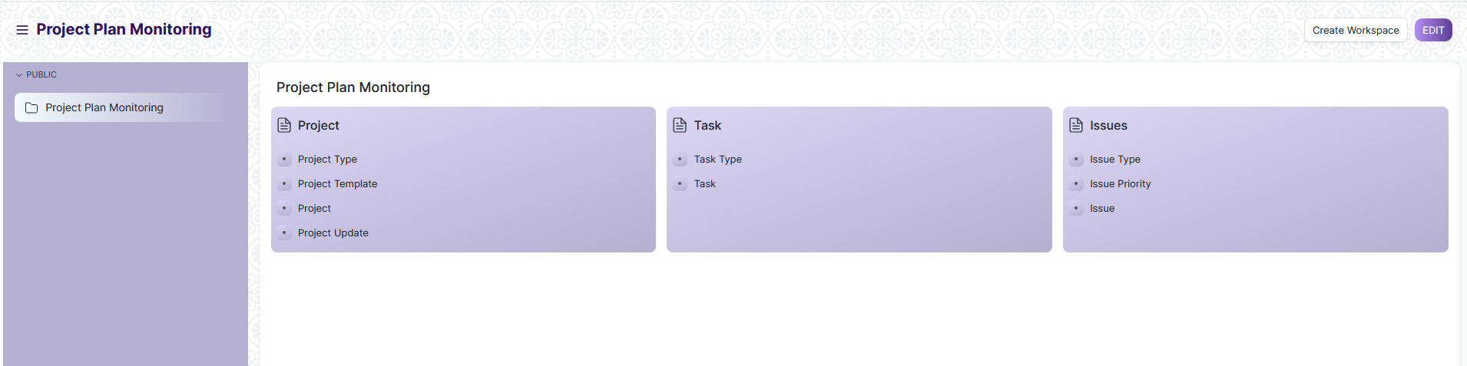

1. Go to the required screen.
2. Click on the ***“+Add Screen Name”*** button in the right corner of the screen.

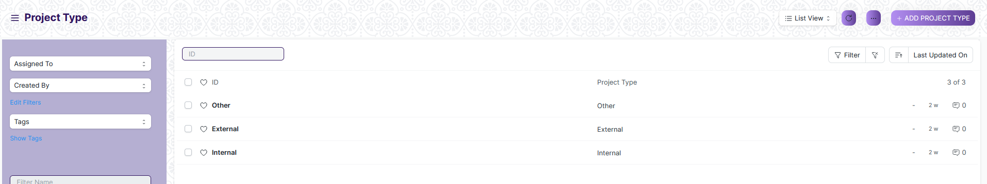

(Example : For addition in the new Project Type form , click +Add Project Type button).

1. Enter the required data.
2. Click on “***Save”*.**
3. After saving , the record will be visible in the List View of the screen.



(Example : List view of saved Project Type)

**Note :** The process of creation can only be carried out by User who have necessary permission.Kindly refer to the Screen wise permission section in the document.

**View a Saved Document**

1. Log in to the system.
2. Go to the required workspace
3. Go to the required screen.
4. Click on the required document from the list view of the screen.



(Example : View of “as” Document of Project Type Screen)

1. View the clicked document.

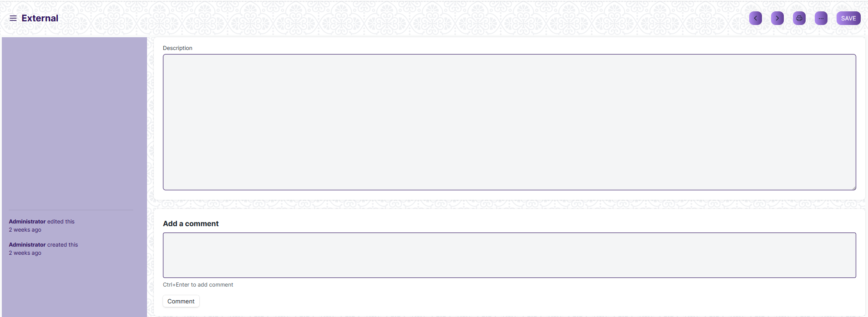

(Example : View of the “as” External)

**Note :** The process of view can only be carried out by user who have necessary permission.Kindly refer to the Screen wise permission section in the document.

**Delete a Saved Document**

1. Log in to the system
2. Go to the required workspace
3. Go to the required screen.
4. Click on the required document from the list view of the screen.
5. Click on the 3 dots in the right corner of the screen.
6. Click on *“****Delete”*.**

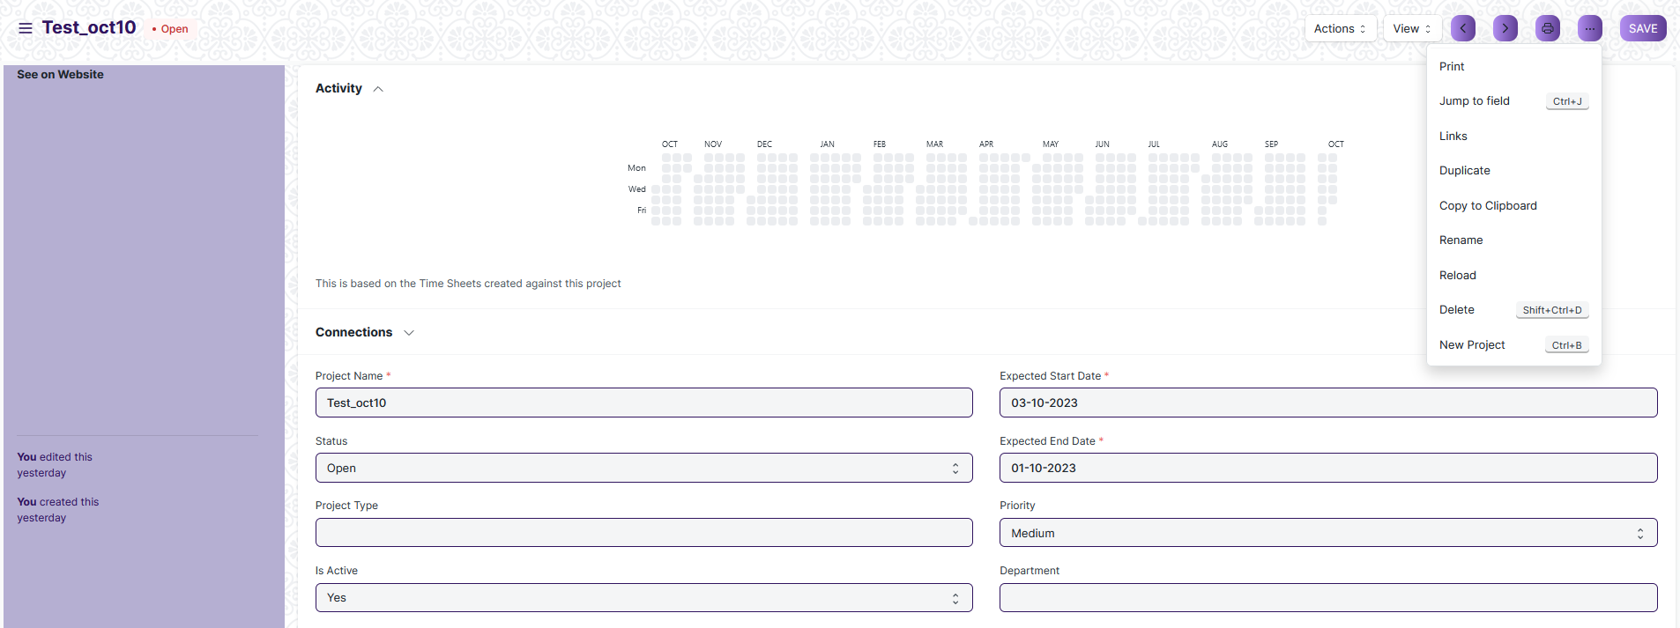

(Example : Deletion of “Test_oct10” document of Project)

1. Click yes if you want to delete the selected document.

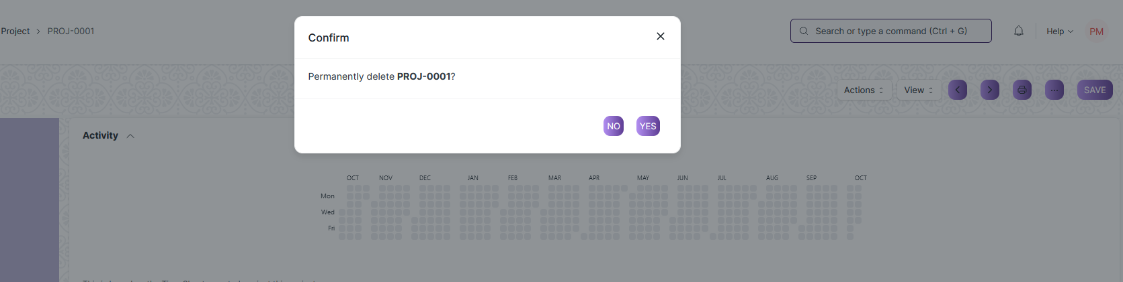

(Example : Clicking Yes to Delete permanently the document)

**Note :** The process of deletion can only be carried out by user who have necessary permission. Kindly refer to the Screen wise permission section in the document.

**Rename a Saved Document**

1. Login to the screen.
2. Go to the required workspace
3. Go to the required screen.
4. Click on the required document from the list view of the screen.
5. Click on the 3 dots in the right corner of the screen.
6. Click on *“****RENAME”*** .



1. Click on *“****Rename”*** button to rename the document.

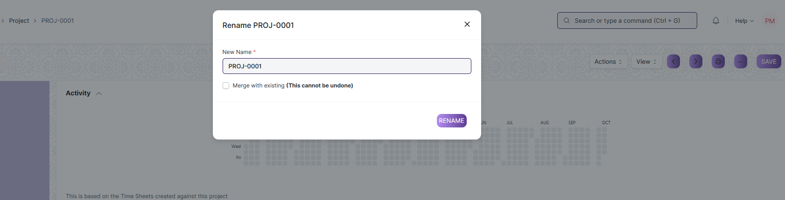

**Note :** The process of deletion can only be carried out by user who have necessary permission.Kindly refer to the Screen wise permission section in the document.

**Print a Saved Document type**

1. Login to the system
2. Go to the required workspace
3. Go to the required screen.
4. Click on a saved document in the screen.
5. Click on the print button present in the right corner of the screen.

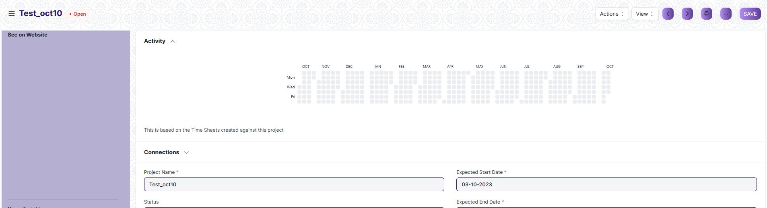

1. A new screen will open.
2. Click on the print button to Print the document.

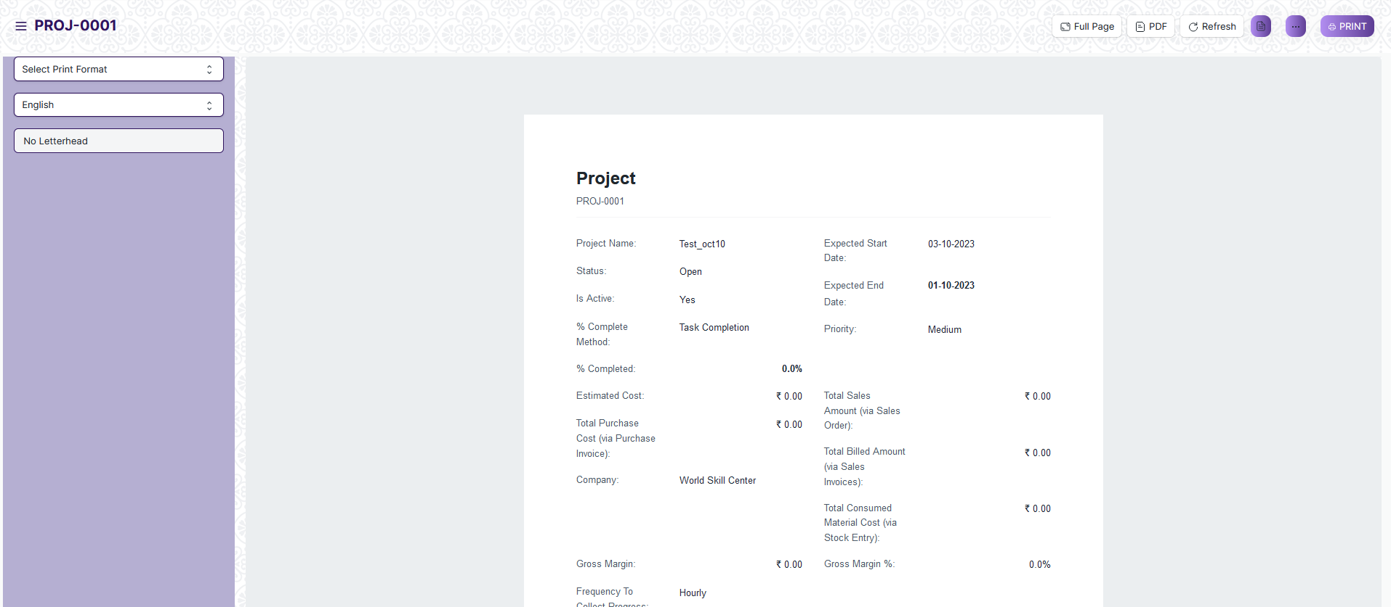

1. To download the employment type as PDF , click on the PDF button .



**Note :** The process of printing can only be carried out by user who have the necessary permission.

**View the saved document in different format.**

1. Login to the system
2. Go to the required workspace
3. Go to the required screen.
4. Click on the List View Button in the screen.

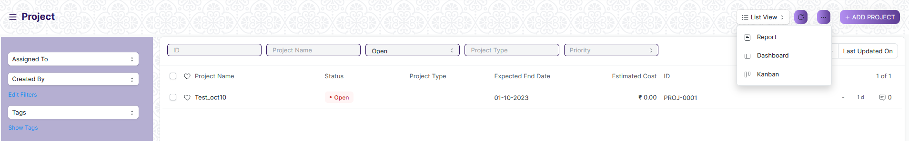

1. Select the appropriate view type that you want.

**Note :** The List view button can only be showed to the user who have necessary permission.

**View the saved documents by applying filters.**

1. Login to the screen.
2. Go to the required workspace.
3. Go to the required screen.
4. Click on the ***“Filter”***.

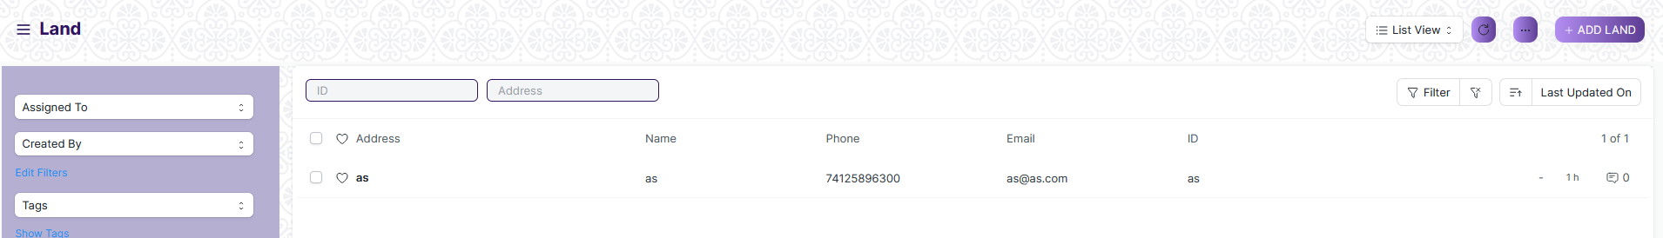

1. Select the field of the document based on which you wish to filter the records. All the fields in a form will be selectable in this list.

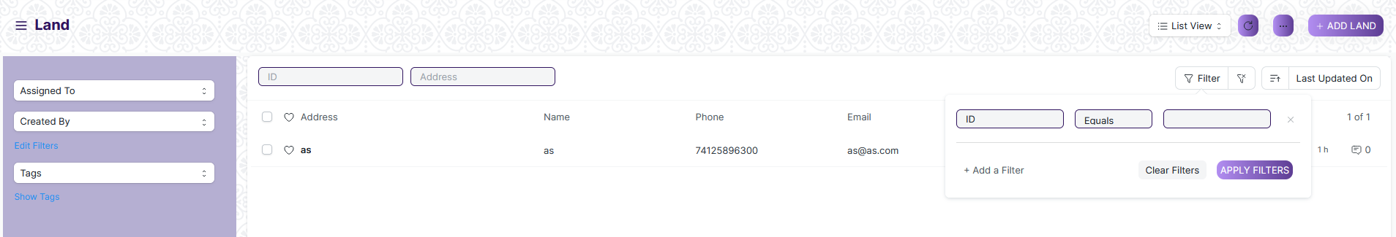

**Based On :** For the field, you will be required to put a value of the field. In the 'based on' field.

**Criteria :** You can define criteria based on which the system will search the document.The different conditions on which the filters are based are: Equals, Not Equal, Like, Not Like, In, Not In, =,>,< etc.

**Value :** Here, you will be required to enter the value for which you are running the document search.

**Some Examples of Viewing the documents in the list view after applying filters.**

Filter on Task type screen where Is Group Equals to Yes. After clicking the Apply Filter button, all the filtered document will show in the screen.

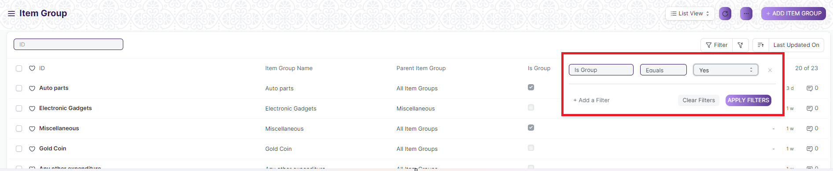

Filter on Task Type Screen where, the Item Group Name starts with ‘A’.

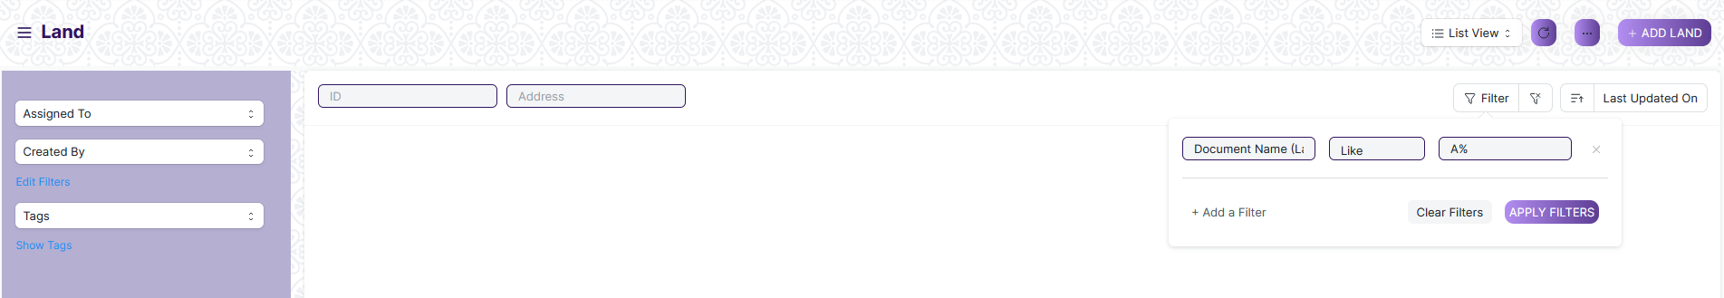

You can also apply multiple filters at a time. To remove a specific filter, just click on 'x' sign on it. To add another filter Click on the +Add a Filter button.

**Example of Multiple filter .**

Applying filter in the Task Type screen , where the Document Name starts with ‘A’. and ID equals as.

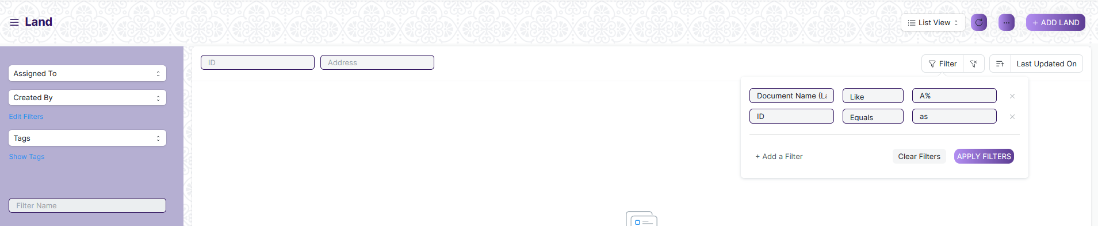

**Default Filters**

There are some filters present out of the box for the views which can be used for filtering the search results.

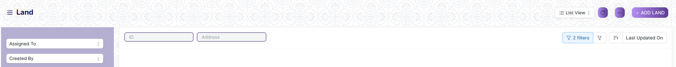

**Note :** The Filter Option can only be showed to the User who have necessary permission.

**General Procedure for a Submittable Screen**

**Create of New document**

1. Login in to the system
2. Go the required workspace
3. Go to the required screen.
4. Click on the ***“+Add Screen Name”*** button in the right corner of the screen.

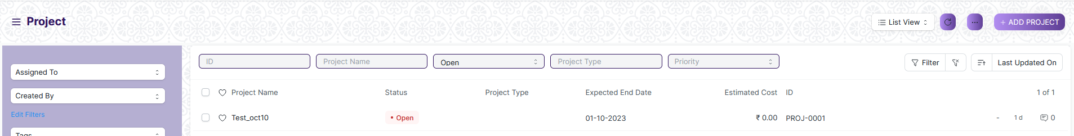

(Example : For addition in the new Floor , click +Add Floor button).

1. Enter the required information in the document.
2. Once you are finished entering the information , click the ***“Save”*** button.
3. After saving it , a submit button will appear.

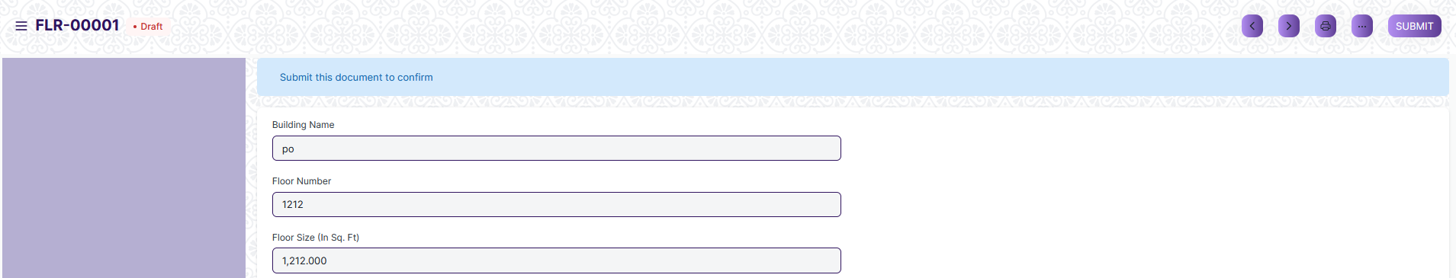

1. Click on the **“Submit”** button.
2. A confirmation dialog box will appear . Click the Yes button to submit the document.

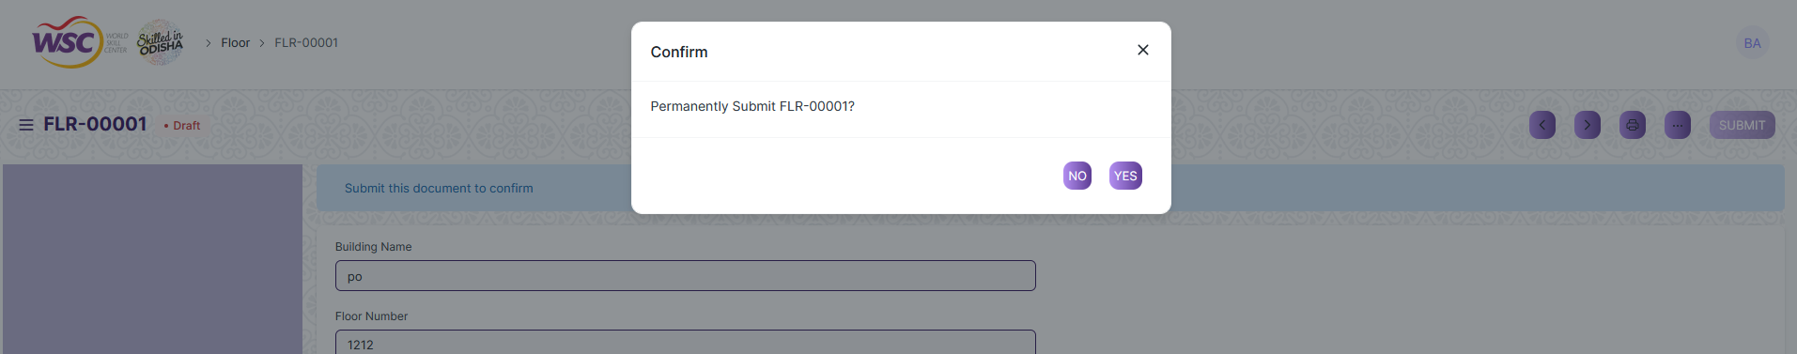

1. After submitting , the record will be visible in the List View of the screen.

**Note :** The process of creation can only be carried out by user who have necessary permission.Kindly refer to the Screen wise permission section in the document.

**Cancel a Submitted Document**

1. Log in to the system.
2. Go to the required workspace.
3. Go to the required screen.
4. Click on the required document from the list view of the screen.
5. Click the ***“Cancel”*** Button.

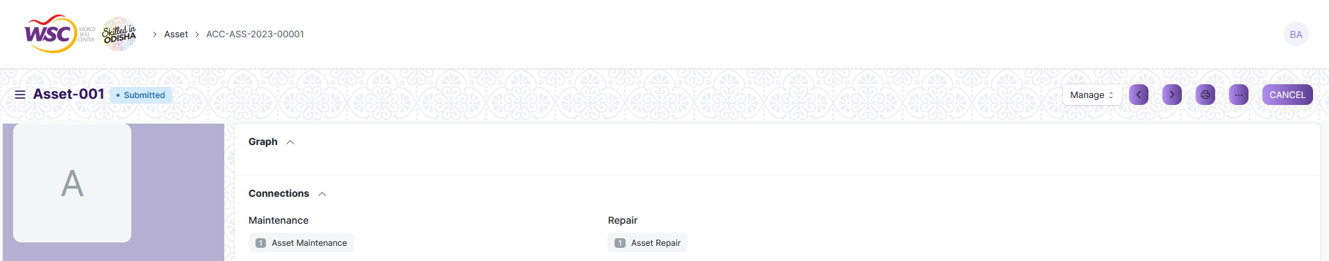

1. A confirmation dialog box will appear . Click the Yes button to cancel the document.

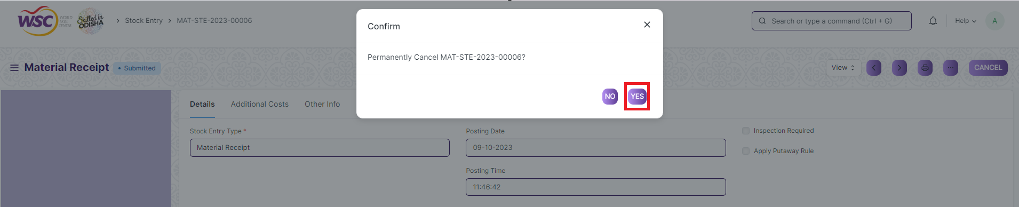

**Note :** The process of cancellation can only be carried out by user who have necessary permission. Kindly refer to the Screen wise permission section in the document.

**Amend a Submittable Document**

1. Log in to the system.
2. Go to the required workspace
3. Go to the required screen.
4. Click on the required document from the list view of the screen.
5. After cancellation of the document , an Amend button will appear on the screen.

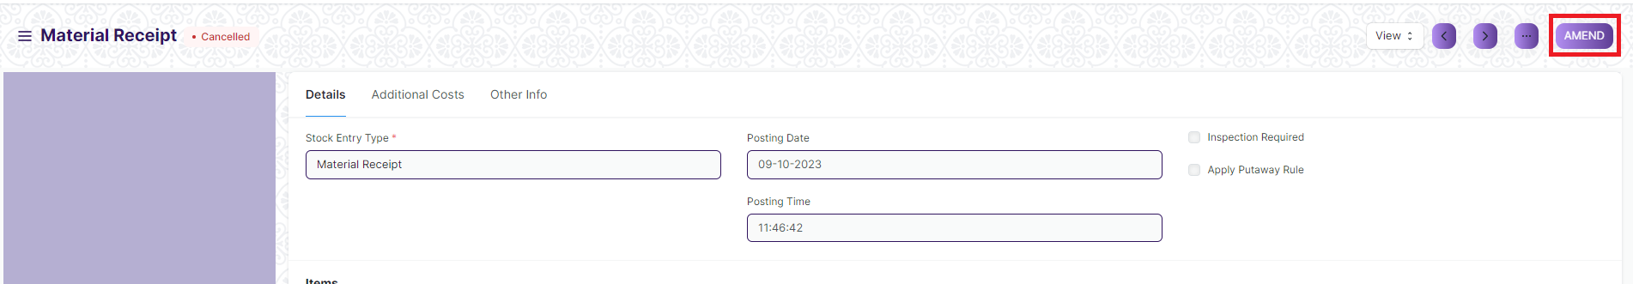

1. Click the “***Amend”*** button.
2. A new document will be created with the same information as the original document .

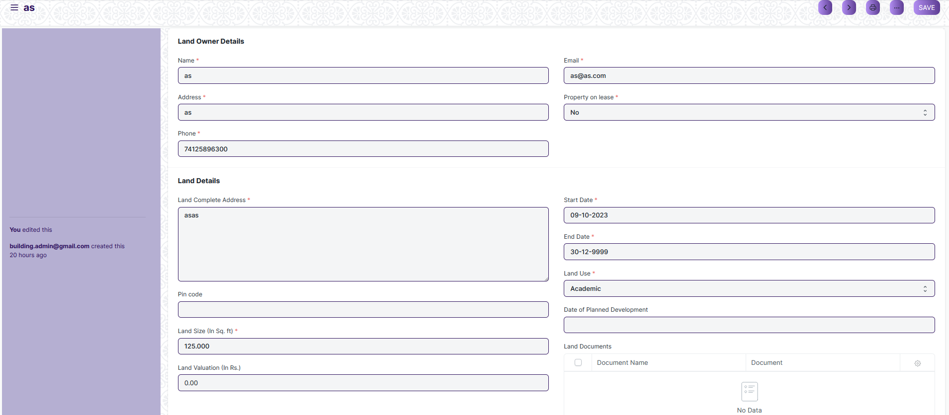

1. You can now make changes to the document as needed.

**Note :** The process of Amend can only be carried out by user who have necessary permission. Kindly refer to the Screen wise permission section in the document.

**Action Menu on a document.**

The three dots menu, located in the right corner of a document in a Screen , offers a range of actions and options to manage and interact with the document.

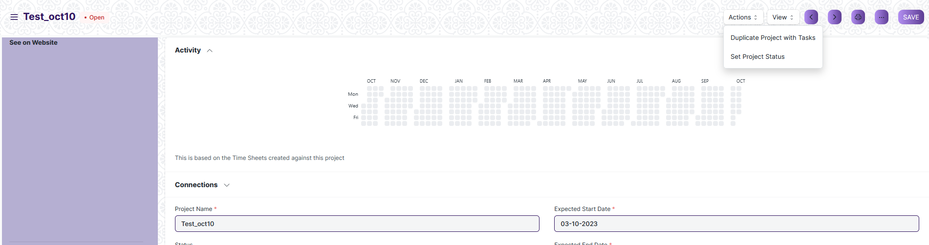

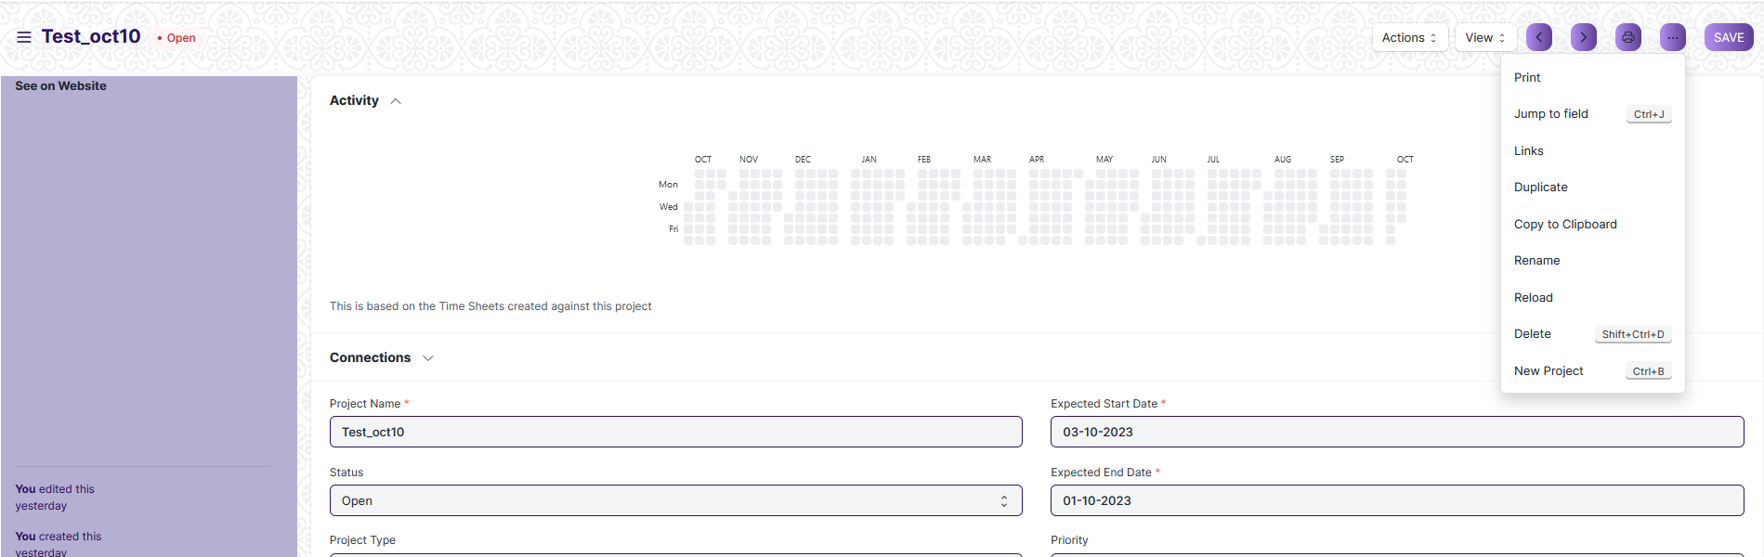

The functionalities available in the three dots menu are given below.

**Print :** Print Enables you to generate a printable version of the document ., which you can save as a PDF or send to a printer.

**Email :** Click on Email allows you to send the document as an attachment via email to specified recipients.

**Duplicate :** Create a new document with the same information as the current one.

**Delete :** Permanently remove the document.

**Cancel :** Cancel the submitted document.

**Submit :** Submit the document . If the document is submittable.

**Links :** This Option displays a list of document that are linked to the current document. You can navigate these linked documents from here.

**Jump to field :** You can directly go the required field by clicking this option and giving appropriate field name.

**Copy to Clipboard :** By clicking this option you can copy the content of the document .

**Rename :** By clicking the Rename option you can Rename the document.

**Note :** These options will be visible to User who have necessary permission.

### Project Type

A Project Type is the classification of projects into different types to group similar kind of projects.

To access the Project Type list, go to:

Home > Project Plan Monitoring > Project > Project Type

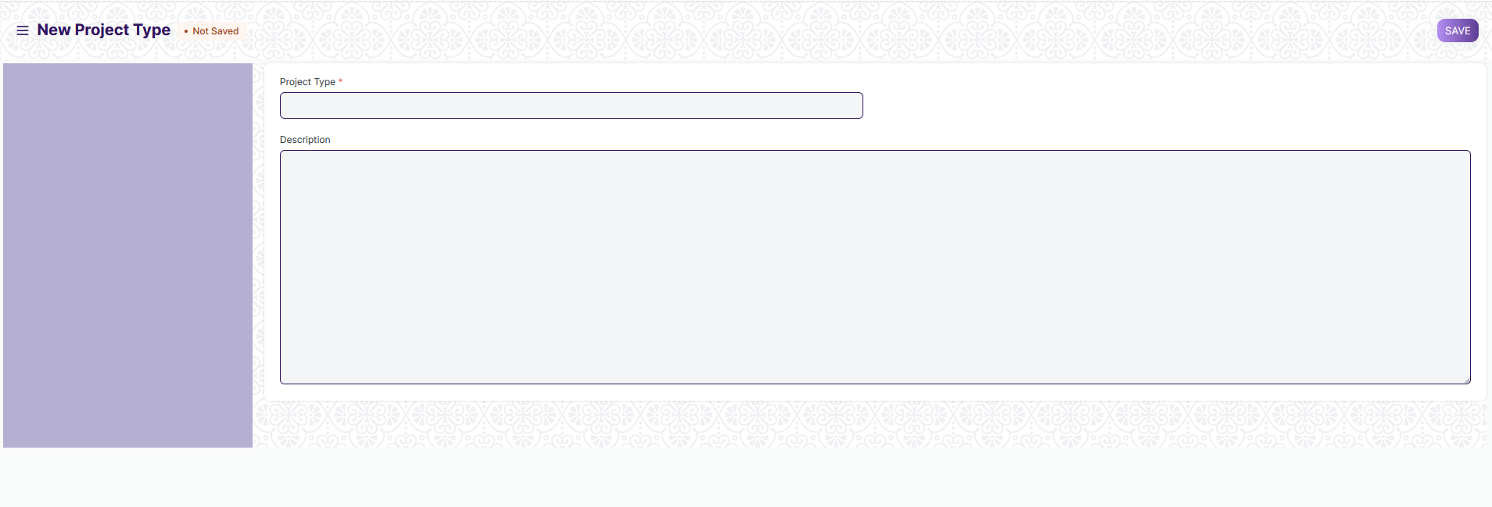

#### 1.1 How to create Project Type

1. Go to the Project Type List and click on New
2. Add the name of the Project Type and description
3. Save

### Project Template

A Project Template is a predefined sequence of tasks arranged in stipulated schedule.

To access the Project Template, go to:

Home > Project Plan Monitoring > Project > Project Template

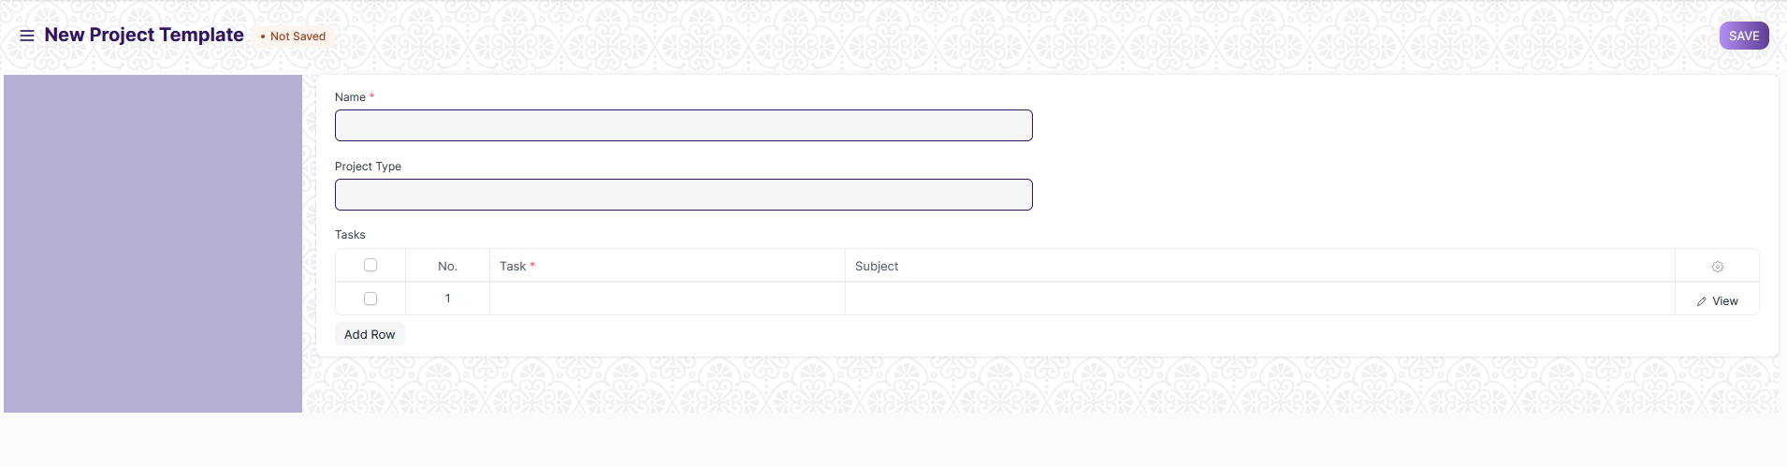

#### 2.1 Prerequisites

Before create Buildings, it is advised that you create the following first:

* Project Type

#### 2.2 How to create an Project Template

1. Go to the Project Template List and click on New
2. Add the following details:
3. Project Template Name: Title of the Project Template
4. Project Type: Project Templates, just like projects can be classified into different project types, e.g., Internal or External
5. Tasks: Each Project Template will have a set of a predefined sequence of tasks. In this table, you can select the tasks you want for this template

### Project

A Project is a planned piece of work that is designed to find information about something, to produce something new, or to improve something.

A Project has a broad scope and hence can be divided into tasks. Think of coming up with a new smartphone for the next year as a Project. Then things like designing, prototyping, testing, delivery, etc. become tasks under the project.

Whilst each task within a Project can be assigned to an individual or a group of individuals, the assignment can also be done at the project level.

These Tasks can be created from a Project itself or a Task can be created separately as well.

To access the Project, go to:

Home > Project Plan Monitoring > Project > Project

#### 

#### 3.1 Prerequisites

Before create Floor, it is advised that you create the following first:

* Project
* Users
* Company
* Cost Center

#### 3.2 How to create Project

1. Go to the Project list and click on New.
2. Add the following details:
3. Project Name: Title of the Project.
4. Status: The default status of a Project is going to be 'Open' which can later be changed to 'Completed' or 'Cancelled'.
5. Expected End Date: Enter the date on which you aim to finish the project.
6. Save.

#### 3.1.1 Additional Options while creating a Project

1. From Template: If you have an existing [Project Template](https://docs.erpnext.com/docs/v13/user/manual/en/projects/project-template), you can choose to create your project using this template.
2. Expected Start Date: If you have a time-line fixed for the project, you can define both expected Start Date and Expected End Date in the form.
3. Project Type: You can classify your projects into different [types](https://docs.erpnext.com/docs/v13/user/manual/en/projects/project-type), e.g., Internal or External.
4. Priority: You can select the priority level of the Project based on how crucial it is. You can also add more priority levels.
5. Department: If the project belongs to, or is owned by a [Department](https://docs.erpnext.com/docs/v13/user/manual/en/human-resources/department) in the organization, you can add that here.
6. Is Active: A Yes/No tab, which lets you change the active status of the project at any later stage.
7. Completion Method: You can track the % completion of your project based on one of the three methods, viz. Manual, Task Completion, Task Progress and Task Weight.

#### 3.3. Features

#### 3.3.1 Users

* **Users**: You can add any [website user](https://docs.erpnext.com/docs/v13/user/manual/en/setting-up/users-and-permissions/adding-users) to give them access to this Project. E.g., you can add your customer as a Website User, to enable them to have access to your project to monitor progress and/or give any inputs/remarks. Similarly, a Supplier or a Contractual Employee/Freelancer who is involved in the Project can be added as a User.
* Further, you can also expand the window and select if you want to send a Welcome Email to any particular user or give them Attachment Viewing rights.
* You can learn more about allowing users to view projects [here](https://docs.erpnext.com/docs/v13/user/manual/en/projects/project-customer-portal).

Notes: You can add any additional notes to the project.

#### 3.3.1 Start and End Dates

* **Actual Start Date**: Basis the Actual Start of the project, tracked via Timesheets, the Actual Start Date and Time of the Project will get recorded automatically.
* **Actual End Date**: Basis the Actual End of the project, tracked via the last update of the Time-sheet, the Actual End Date and Time of the Project will get recorded automatically. To know more about Time-sheets

#### 3.3.2 Costing and Billing

* **Estimated Cost:** Enter the Estimated Cost of the Project.
* **Total Sales Amount:** If you have already linked the Project with a Sales Order, the Total Sales Order Amount will be auto-populated here.
* **Total Costing Amount:** The system will automatically fetch the Total Costing Amount from all the Time-sheets linked to this project.
* **Total Billable Amount:** The system will automatically fetch the Total Billable Amount from all the Time-sheets linked to this project.
* **Total Expense Claim:** Based on the expenses claimed by an [Employee](https://docs.erpnext.com/docs/v13/user/manual/en/human-resources/employee) for the completion of the Project, the Total Expense Claim will be auto-calculated.
* **Total Billed Amount:** The Total Billed Amount gets auto-populated in the system using the Sales Invoice created against the Sales Order.
* **Total Purchase Cost:** The Total Purchase Cost of a Project is the cost fetched from the Purchase Invoices that get created against a Purchase Order issued for supply of Materials required for a Project.
* **Total Consumed Material Cost:** Using the Stock Entry made as per the requirement of Materials in the Project, the Total Consumed Material Cost gets captured.

#### 3.3.4 Monitor Progress

* When you enable the 'Collect Progress' option by checking the box, it will enable you to add monitoring details to the project. A report on the progress of the project shall be sent to all stakeholders of the project.
* **Holiday List:** You can select the Holiday List for your company. This will allow you to collect the Progress Reports only on the Working Days.
* **Frequency:** You can set the frequency at which you wish to get the reports. It can be set to an hourly, twice daily, daily or on a weekly frequency.

1. **Project Update**

A Project Update is the status of the Project which can be sent to all the stakeholders of the Project.

To access the Project Update, go to:

Home > Project Plan Monitoring > Project > Project Update

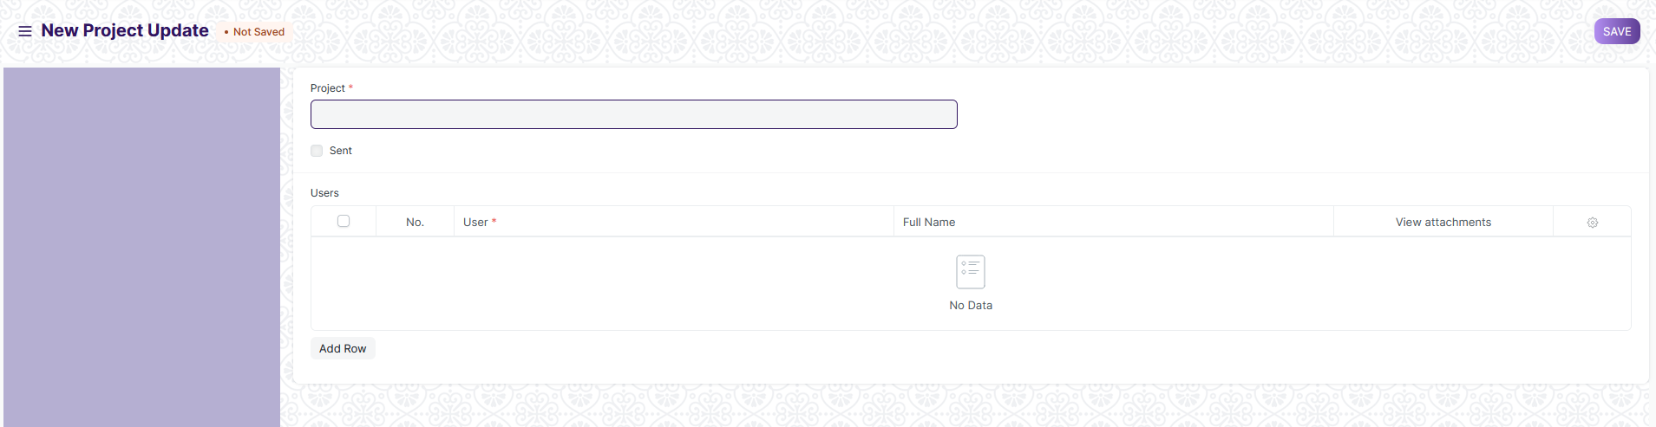

#### 4.1 How to create **Project Update**

1. Go to the Project Update List and click on New.
2. Add the name of the Project for which you want to send an update.
3. Add the name of the Users to whom you want to send the Project Update in the Child Table. These Users could be your Customers or any other Internal or External Stake Holders.
4. Save and Submit.

#### 4.2 Additional Details

When you expand the table which has the names of the users, you will be able to add the following details:

1. You can select whether you want to send a Welcome Email to any particular User while sending them the Project Update
2. You can select whether you want any particular User to view Attachments in the Project Update
3. You can add the description of the Current Stage of the Project in the 'Project Status' field
4. **Task Type**

"Task Type" refers to a categorization or classification of tasks within the system. Tasks are activities or work items that need to be completed, and organizing them by task type can help in managing and tracking various types of work within an organization.

To access the Task Type, go to:

Home > Project Plan Monitoring > Task > Task Type

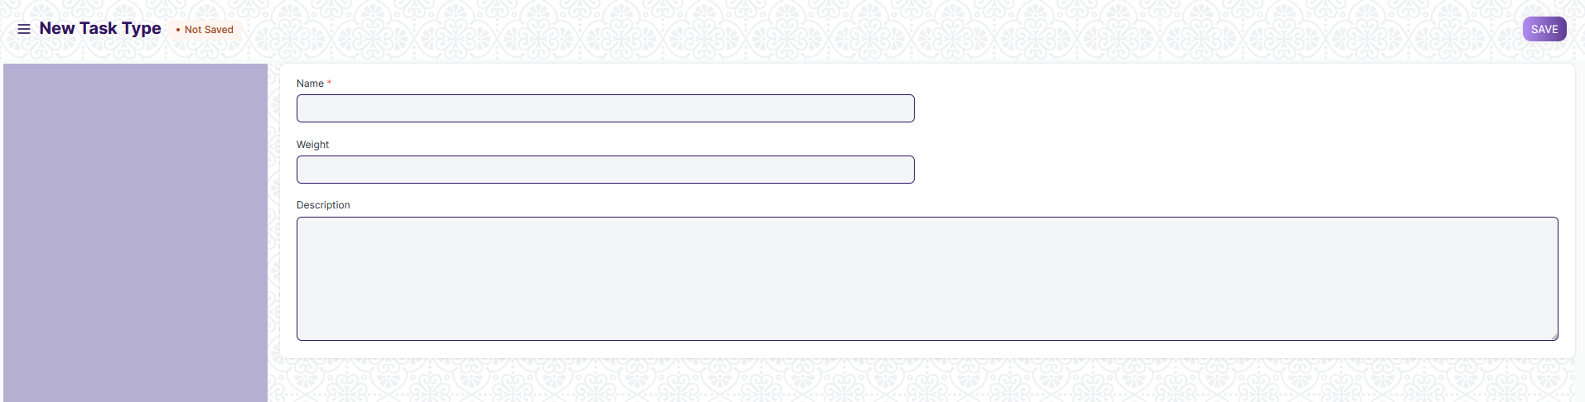

#### 5.2 How to create Task Type

1. Go to the Task type list and click on New.
2. Enter Name, Weight and description.
3. Click on Save.
4. ****Task****

**A** task is an actionable unit or activity which needs to be completed.

To access the Task, go to:

Home > Project Plan Monitoring > Task > Task

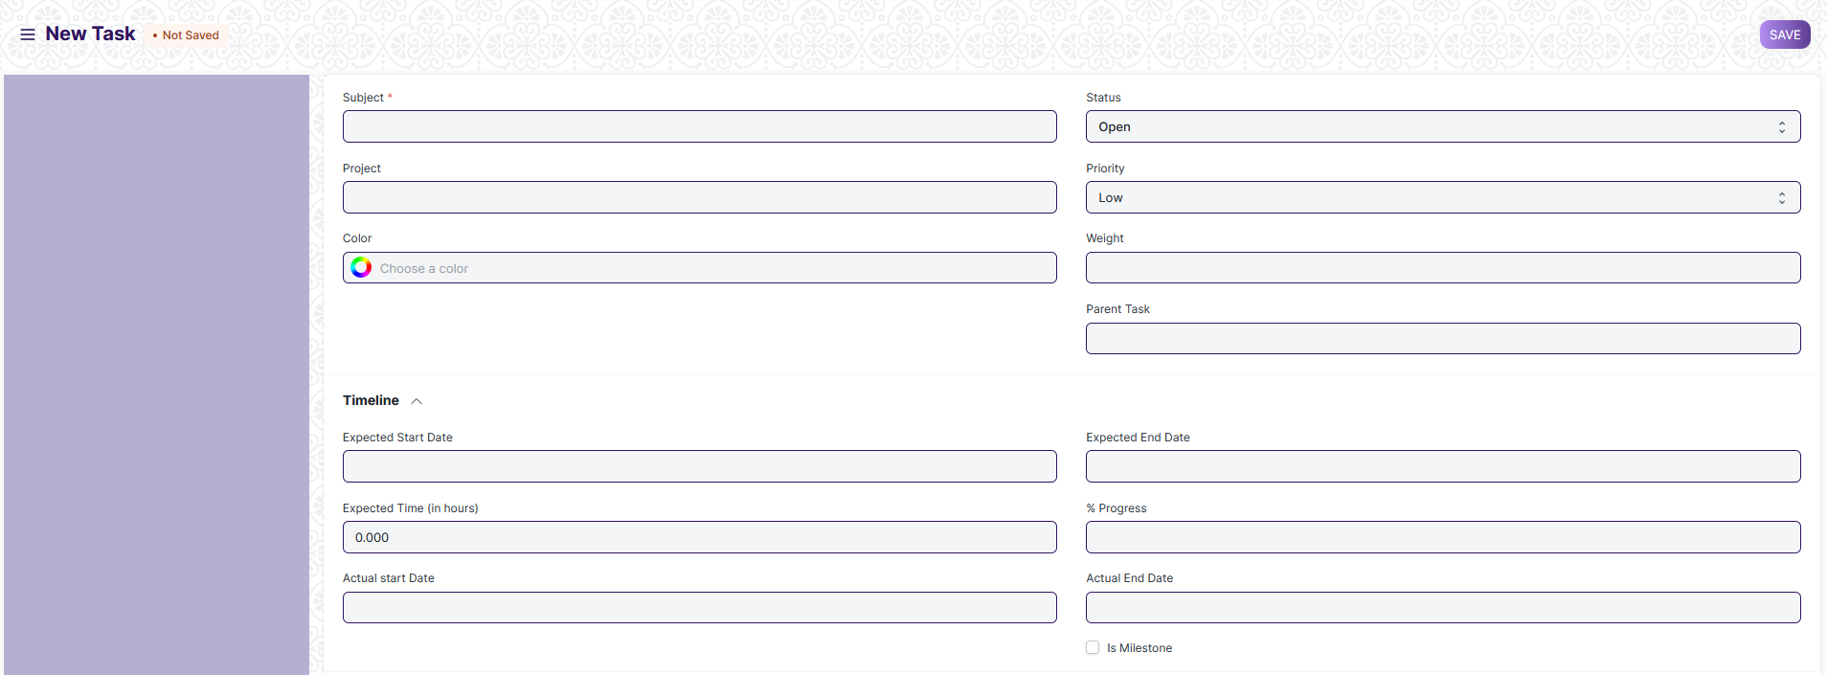

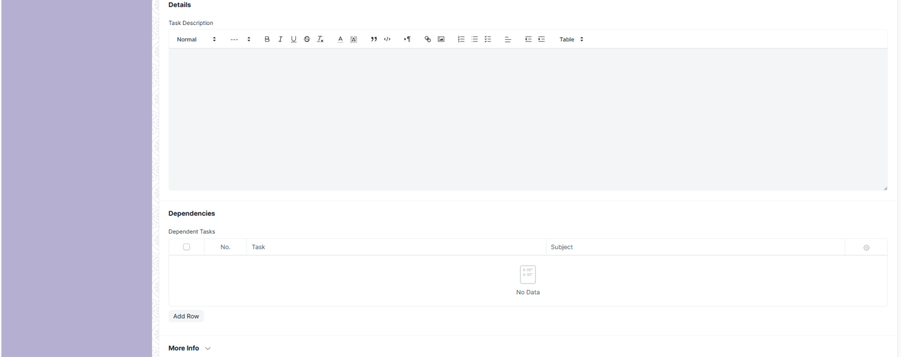

#### 6.1 Prerequisites

* Task Type

#### 6.2 How to create an Task

1. Go to the Task List and click on New.
2. Add the subject of the task.
3. **Save.**

**Alternatively, a task can also be created from a Project in the following way:**

1. Go to the Project for which you want to create a new task.
2. Go to Task under the Project section on the Dashboard. The plus icon '+' here would direct you to the task creation page.
3. Add the subject of the task.
4. Save.

#### 6.2.1 Additional Options while creating a Project

**The following additional details can be added when editing a new task:**

* **Status**: You can add the status of the Project or change the same whenever needed, e.g., from 'Open' to 'Working', 'Overdue','Pending Review','Completed', or 'Cancelled'
* **Project**: In case a task is added independently, you may choose to link the task to a particular Project. If the task is created from a Project, the details of the Project will get automatically added.
* **Priority**: You can choose to define the priority of the task, viz., Low, Medium, High or Urgent.
* **Issue**: If the task is an actionable that arises out of an Issue, that issue can be tagged here with the Task.
* **Weight**: If a particular task carries some weightage out of a project, or otherwise, the weightage can be specified here. This weightage gets calculated in the Percentage Task Completion Method by Task Weight.
* **Type**: If your task can be defined under a particular Task Type, say, User Training or User Demo, you can enter the Task Type here. It can be used to filter the Tasks based on Task Types.
* **Color**: Each task can be recognized by a different color. This helps in identifying a task while creating Gantt Charts.
* **Is Group**: This box can be checked to indicate that a task is a parent task, and can be further divided into multiple sub-tasks.
* **Is Template**: This box can be checked to indicate that this task is a template task, and is meant to be used in a Project Template.
* **Parent Task**: If a particular task is a part of a group task, the parent task can be linked to the task from this field.

#### 6.2.2. Timeline and Details

* **Expected Start Date**: You can enter the date on which you expect the Task to be started.
* **Expected End Date**: You can enter the date on which you expect this Task to be finished.
* **Expected Time**: You can enter the number of hours which you expect are going to be spent on this task.
* **Progress**: You can enter the Progress Percentage of a Task.
* **Begin**: If the task is a template task, this field can be used to specify the day on which this task should begin after the project is commenced.
* **Duration**: If the task is a template task, this field can be used to assign a specific number of days to this task.
* **Is Milestone**: This box can be checked in the cases where a particular task is a Milestone in a Project.
* **Description**: You can add a description of the task here.

1. ****Issue Type****

Issue Type is useful for tagging and classifying Issues.

The maintenance activities can be cleaning, polishing, servicing, or any other activity required to maintain the Asset in good condition.

To access the Issue Type, go to:

Home > Project Plan Monitoring >Issues > Issue Type

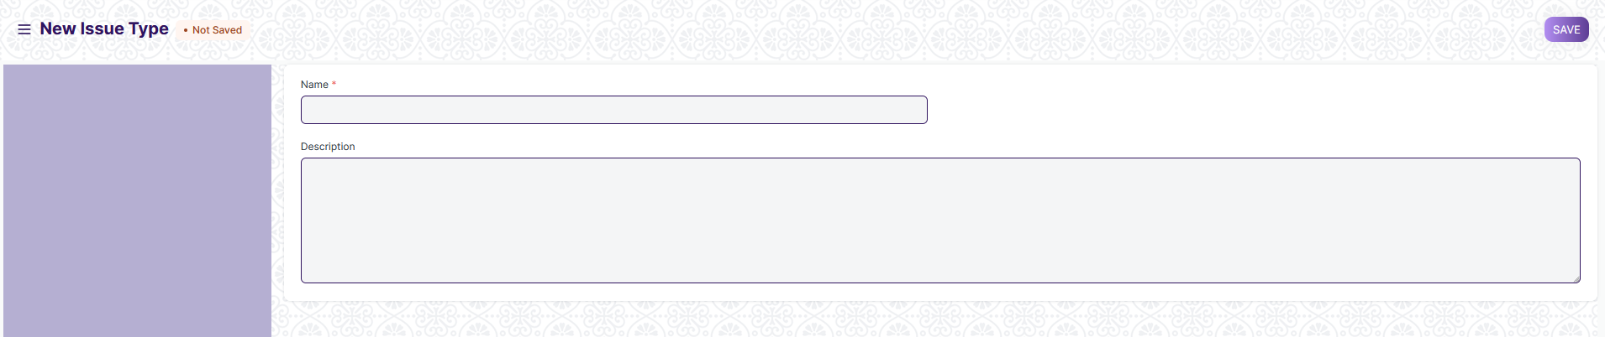

#### **7.1 How to create an Issue Type**

1. Go to the Issue Type, click on New.
2. Enter a name for the type.
3. Enter description.
4. Save.
5. ****Issue Priority****

**Issue Priority indicates the urgency of solving an Issue**

To access the Issue Type, go to:

Home > Project Plan Monitoring >Issues > Issue Priority

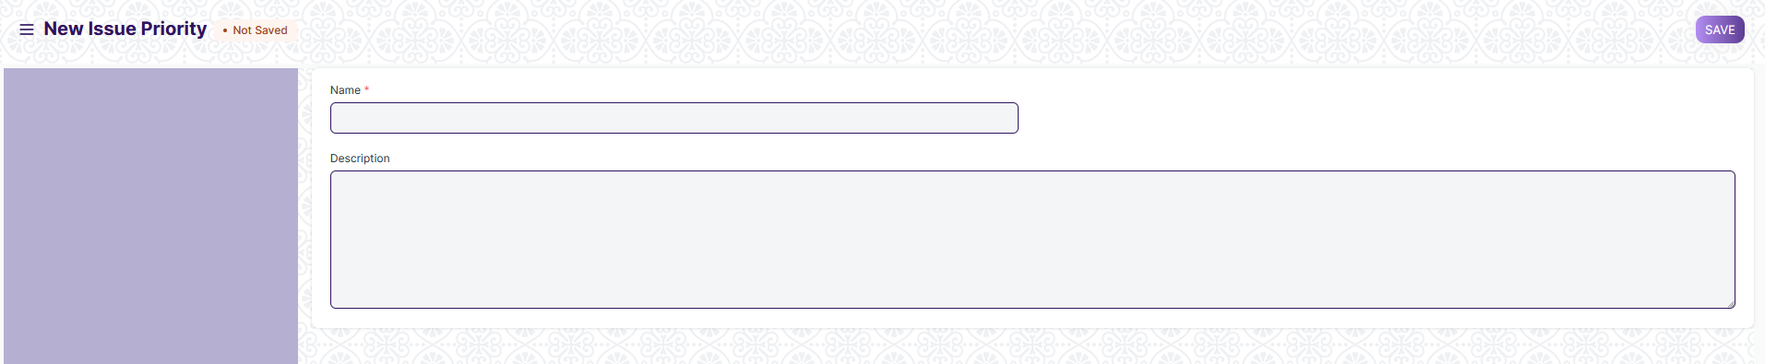

#### **8.1. How to create Issue Priority**

1. Go to the Issue Priority list, click on New.
2. Enter a name and description for the type
3. Click on Save.
4. ****Issue****

An Issue is an incoming query.

To access the Issue, go to:

Home > Project Plan Monitoring >Issues > Issue

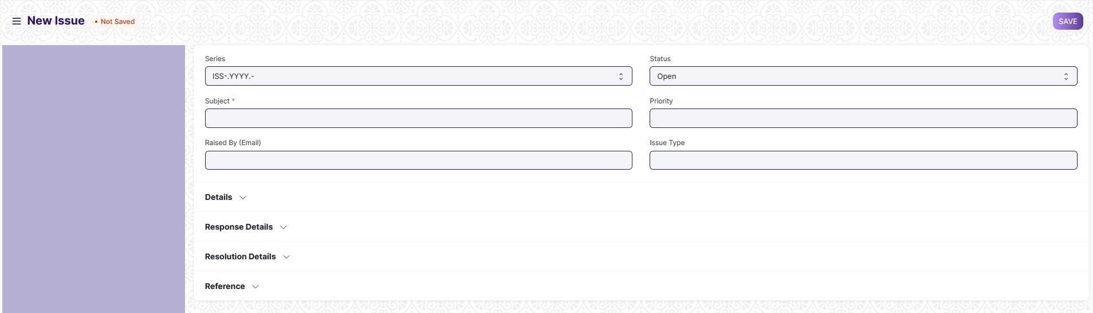

#### **9.1 Prerequisites**

* Issue Type
* Issue Priority

#### **9.2 How to Create Issue**

1. Go to the Issue list, click on New.
2. Enter the Subject, Raised By, and a description of the Issue.
3. Save.

#### **9.2.1 Additional Options when Creating an Issue**

* **Status**: When a new Issue is created, its status will be "Open", when it is replied, its status becomes "Replied".
* **Open**: The Issue has been created and yet to be replied to.
* **Replied**: A reply has been sent to the Issue.
* **Hold**: The Issue is on Hold due to some reason.
* **Resolved**: When the users are reasonably sure that they have provided the customer with a solution to their problem but have not received an acknowledgment about the resolution from the customer.
* **Closed**: The Customer got a satisfactory resolution that he has indicated with an acknowledgment and the Issue was closed.
* If the sender replies to the thread, the status becomes "Open" again. User can "Close" the Issue manually by clicking on the Close button on the top right.
* Priority: Priority can be set as per the requirements. By default, there are three priorities--Low, Medium, and High. You can delete these or add more as needed.
* Issue Type: An Issue can be classified using Issue Type. Examples of Issue Types can be: 'Functional', 'Technical', 'Hardware', etc.
* Raised By (Email): The email ID from which the Issue was sent will be shown here.

#### **9.2.2 Resolution**

* Opening Date: When the issue is created or logged the date be posted.
* Opening Time: When the issue is created or logged the exact time will automatically be posted.
* Resolution Date: When the user resolved the issue, Date and Time will get updated in this field.
* Resolution Details: User can enter the details of the issue, once it is resolved. This is a text field. Also, user can upload the image, enter or create a table.
* Resolution Time: Total time taken to close the ticket (from Issue creation to closing).
* User Resolution Time: Many times a user has to wait for a customer's reply in order to solve some Issue. While measuring User's productivity this wait time shouldn't be taken into consideration. Hence, user resolution time is the total time taken by a user to close the ticket and can be calculated as:
  + Resolution time - Total Time for which the user had to wait for a customer's reply

The Resolution Time and User Resolution Time metrics are set on "Close". These metrics reset automatically when the Issue reopens or splits.